 | National Junior College  SH2 Preliminary Examinations for General Certificate of Education Advanced Level  Higher 2
GEOGRAPHY |  | 9173/02
Paper 2
INSERT |  | 10 September 2024  3 hours
READ THESE INSTRUCTIONS FIRST

This Insert contains all the Resources referred to in the questions.

This document consists of 8 printed pages.
Resource 1 for Question 1
Map of Toa Payoh

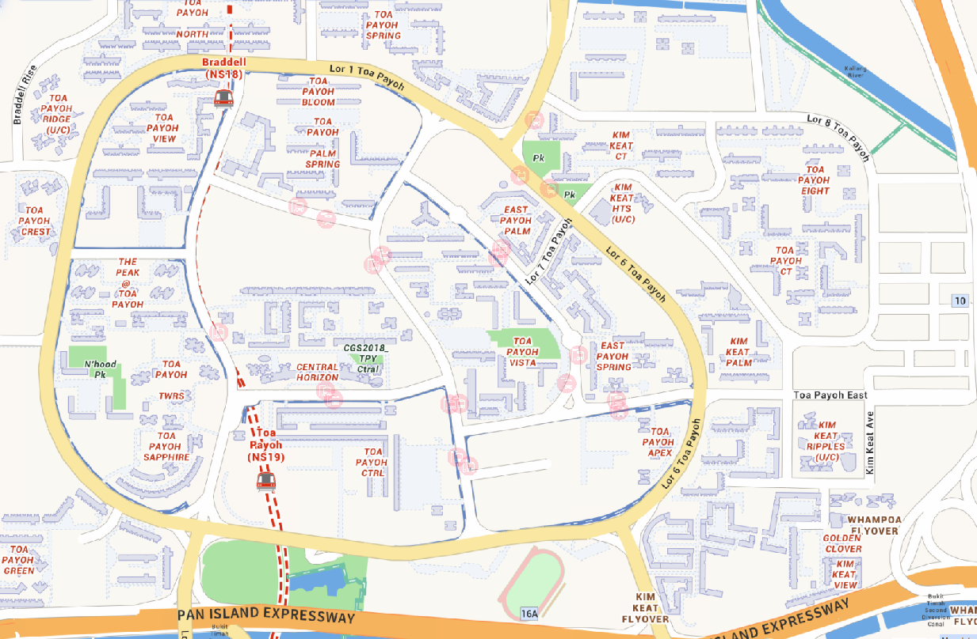
Location for Toa Payoh Integrated Development
Toa Payoh HDB Hub

Legend
 | Mass Rapid Transit (MRT) Station
 | Names shown in red capital letters are the names of residential estates in Toa Payoh
U/C | Under construction
Pk | Park

Resource 2 for Question 1
Article on Toa Payoh Integrated Development
Distinctively Toa Payoh! Upcoming New Integrated Development

Envisioned to be an extension of Toa Payoh Town Centre to serve the residents in the central region, it will be a lifestyle destination with community facilities and space. A Regional Sport Centre, a Polyclinic, a Public Library and a Regional Town Park are being planned on the 12 hectares land parcel located between Lorong 6 Toa Payoh and the Pan Island Expressway (PIE).

“We will continue to rejuvenate our town, so that Bishan-Toa Payoh and Marymount neighbourhoods will remain a good home for residents of all ages. I thank our agencies and partners for working together on this project, which will allow our residents to benefit from the upgraded polyclinic, library, park and sporting facilities,” said Mr Chee Hong Tat, Senior Minister of State, Ministry of Finance and Transport and Adviser for Bishan-Toa Payoh Grassroots Organisations.

The proposed sporting facilities, such as swimming pools, indoor sports halls, sheltered tennis, futsal and netball courts, gymnasium and fitness studios, and a football stadium, will create opportunities for the community to come together and bond through sporting activities. At the same time, these elements will also help people achieve their health and wellness goals.

The polyclinic within the new development is part of Ministry of Health’s (MOH) plan to invest in primary care, and to enable Singaporeans to receive care closer to home. With an ageing population and the prevalence of chronic diseases, there will be a shift in focus towards preventive health and early intervention to encourage the public to take charge of their own health. The redeveloped Toa Payoh Polyclinic, co-located at its new site within the new Toa Payoh Integrated Development with community and sports facilities, is well placed to meet the needs of the residents, from providing regular assessment for healthy child development to senior services such as frailty screening and health promotion interventions to encourage healthy and active ageing.

Toa Payoh Town Park will be rejuvenated as part of the overall Toa Payoh Integrated Development with enhanced greenery and new amenities, bringing visitors closer to flora and fauna. Research has shown that being amidst nature contributes positively to mental resilience and improves well-being.

Resource 3 for Question 1
Survey questionnaire crafted for the investigation
Age:
Race/ethnicity:
- What are some activities you do in your free time?
- Where are some places you enjoy spending time at in Toa Payoh?
- How often do you spend time with family and friends?
- Do you approach your neighbours for help in times of need?
- On the scale of 1 to 5, with 1 being the least satisfied and 5 being the most satisfied, how satisfied are you with the ability of Toa Payoh to meet your needs?
- What are some reasons for your satisfaction level?
- What do you think can be improved on in Toa Payoh to meet your needs?

Resource 4 for Question 1
Selected responses for Question 7 of the Questionnaire in Resource 3
“What do you think can be improved on in Toa Payoh to meet your needs?”
Respondent | Response
A | More activities organized for us to help us to stay healthy and spend time with friends
B | More facilities that are elderly friendly
C | Activities organized by the community centre can be held more often for us to learn new skills and keep up with the times better
D | Places that elderly can gather to socialize without having to spend much money
E | More tables and chairs at the void deck
F | Activities to get to know neighbours better
G | Activities for the elderly to be held nearer to my home for them to be more accessible to me

Resource 5 for Question 2
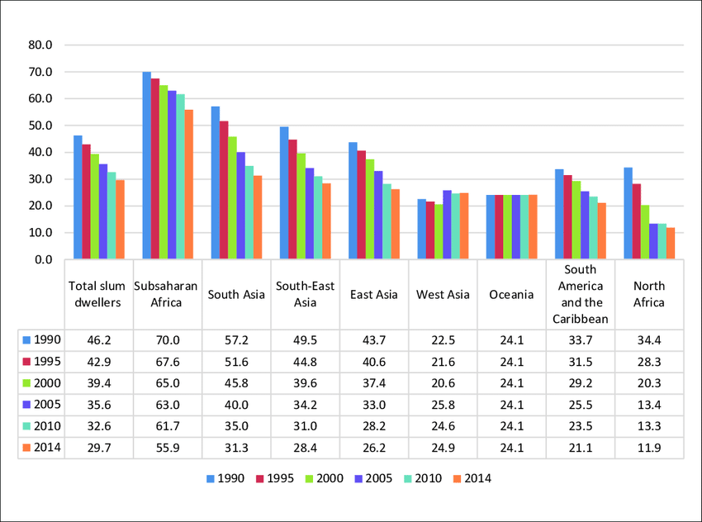
Urban slum populations in developing regions from 1990 to 2014
Share of urban population living in slums (%)

Resource 6 for Question 2
Article on women’s lives in slums
Women’s Lives in Slums
It’s not only wives and mothers who migrate to the city. Many young girls like Aloka, are pulled out of school and sent to work in cities so that they can send money back home. These girls usually begin by assisting a relative with their domestic work, then, once trained enough, they are sent to find work on their own.

These are the women who populate the habitations of the urban poor, the ones who flock to the low cost, overcrowded slums. Their 16-to-17-hour workday involves multiple dimensions of poverty, including lack of access to basic services which would have otherwise aided them in reducing the length of their work day effectively.

The neighbourhoods where these women live are often in slum areas, which are far from the places where they work every day. Commute expenses and time spent on travelling, are all on the costlier side as compared to the amount these women manage to earn every day.

Though they technically earn more than they did back in the villages, their lifestyle reflects much less of their overall upward economic mobility. In urban areas these women become significantly poorer – especially given that basic needs (food, shelter, transportation, clothing etc) are more expensive in the city.

Life in the slums is by no means easy for women. The overcrowded shacks and buildings are mostly illegal settlements and consequently lack basic infrastructure services like water, sanitation and health facilities. The lack of basic services affects women disproportionately because they spend most of their unpaid work hours attending to their care-giving roles at home.

Women also suffer from security threats when they travel to and from their work on public transport. The more visible these women are in roles outside their homes, the more they are targeted for various kinds of assaults, as they somehow come across as vulnerable and unprotected by the formal system of institutional support.

Resource 7 for Question 2
Oxygen isotope (¹⁸O) data in ocean cores for the last 500,000 years

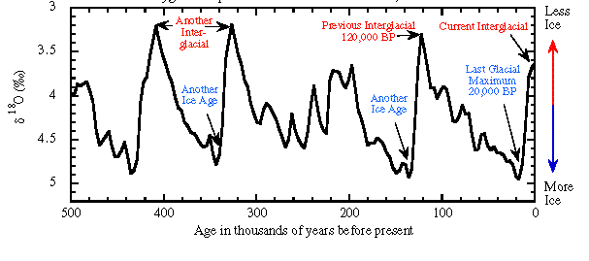
¹⁸O (%)

Resource 8 for Question 2
Cartoon on climate change
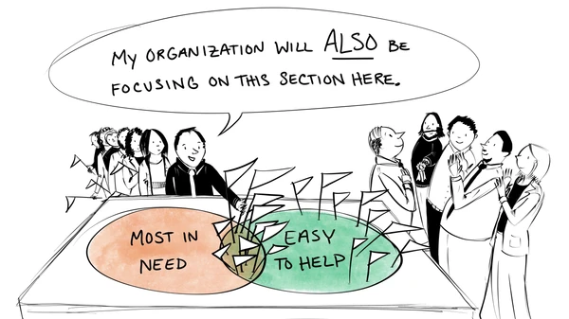

Copyright Acknowledgements
Question 1 Resource 1 | © OneMap. (2023). https://www.onemap.gov.sg/
Question 1 Resource 2 | © National Healthcare Group Polyclinics. (2023). Distinctively Toa Payoh! The new integrated development to capture the rich heritage and existing greenery while incorporating new technologies to create opportunities for a seamless health and wellness experience for residents. In National Healthcare Group Polyclinics [Press Release]. https://www.nhgp.com.sg/Lists/News/Attachments/659/MediaRelease_ToaPayoh_Integrated_Development_Public_Exhibition_Final.pdf /
Question 1 Resource 3 | © National Junior College
Question 1 Resource 4 | © National Junior College
Question 2 Resource 5 | © Rudewicz, J. (2020). Entrepreneurship in Slum Dwellers: Social Inclusion and the “Right to a City.” Entrepreneurship - Education. https://doi.org/10.24917/20833296.162.25Entr
Question 2 Resource 6 | © Henrietta. (2022, June 15). Gender Discrimination: Women’s Rights & Lives in slums. Habitat for Humanity GB. https://www.habitatforhumanity.org.uk/blog/2018/09/gender-discrimination-slums/
Question 2 Resource 7 | © Doherty, P. (2008). Paleotemperature. http://www.exo.net/~pauld/workshops/Paleoclimate/paleotemperature.html
Question 2 Resource 8 | © Vice Asia Staff. (2020, August 9). The sad state of climate change in 8 cartoons. VICE. https://www.vice.com/en/article/z3eax5/climate-change-problems-art-illustrations-editorial-cartoons-commentary

